Real Estate Capital Market Analysis

In-Class Mid-Term Exam, March 4, 2026
Two Hour (6:00 pm – 7:50 pm)

Total examination 100 points (worth of 24 points to Final Grades)

1. Determine the scheduled balances of the following 30-year mortgages at the end of the fifth year. (Total 10 points)
Mortgage Original Amount ($) Contract Rate (%) Balance
A 100,000 8 ____________
B 90,000 7 ____________

Hint: The scheduled balance of a standard fixed-rate mortgage at any time is equal to the present value of the remaining payments discounted by the rate on the mortgage.

2. Suppose that a lender offers you a 15-year, monthly payment mortgage for $200,000 at 6% with two discount points. (Total 20 points)
a. Calculate your monthly payment; (5 points)
b. What is the APR on this loan; (5 points)
c. What is the effective cost (in APR) if the loan is repaid at the end of the year 5? (10 points)

3. Mortgage monthly Payment calculation: (total 20 points)
3a. For a 30-year fixed-rate fully amortized mortgage with mortgage rate 6.00% and initial balance of $200,000, what is the scheduled monthly payment? (no need to consider tax and insurance for this exercise); (5 points)

3b. Another 30-year fixed-rate mortgage with mortgage rate 6.00% and initial balance of $200,000 has an initial interest-only term of 5 years, followed by 25-year fully amortization term. (5 points)
- What is the monthly payment for the first 5 years?
- What is the monthly payment for the remaining 25 years?
- What is the monthly payment increase in dollar and in percentage from the interest-only periods to amortization periods?

3c. At the end of 5 years, market 30-year mortgage rate drops to 4.00%, assume no cost for refinancing, you decide to refinance your existing mortgage with the new rate and 30-year term.
- What are your monthly savings you expect to have from refinancing the loan from scenario 3a? (5 points)
- What are your monthly savings you expect to have from refinancing the loan from scenario 3b? (5 points)

4. Interest Rate Risk of Mortgage Loan (total 20 points)

Assume an investor purchased a 30-year fixed-rate fully amortized mortgage loan of balance $100,000 and mortgage rate of 8% at par (pays $100,000).

Right after the purchase, market 30-year mortgage rate went up to 8.5%.
4-1a. If he assumed the borrower will pay the mortgage to the full term, what is his estimated loss due to the rate increase? (4 points)

4-1b. If he estimated that the borrower would pay off the mortgage at the end of 3 years, what is his estimated loss due to the rate increase? (4 points)

4-1c. Which scenario did he have a higher loss? What do you learn from this exercise? (4 points)

Right after the purchase, market 30-year mortgage rate went down to 7.5%.
4-2a. If he assumed the borrower will pay the mortgage to the full term, what is his estimated gain due to the rate decrease? (4 points)

4-2b. Based on your estimated market value of the mortgage at rate 8.5% and 7.5%, what is the estimated Effective Duration in years if the mortgage will be held to it full term? (4 points)

5. (Total 10 points) WAL (weighted Average Life) of two mortgage loans.

There are two 30-year residential fixed-rate mortgage loans:
Loan 1: loan amount $200,000, mortgage rate 6.50%, fully amortized in 30 years, and is expected to pay according to amortization schedule;
Loan 2: loan amount $100,000, mortgage rate 6.00%, while fully amortized in 30 years, but expected to pay off at the end of year 5.

Question 5-1: calculate the average life (AL) for Loan 1 and Loan 2, respectively;
Question 5-2: Calculate the weighted average life (WAL) of the Loan 1 and Loan 2 combined.

6. (Total 20 points) Risk and Return Measures of Sample Fannie Mae 30-year MBS with CUSIP 314M7GU9 as of 1/30/2026

Chart 6-1: MBS Attributes of CUSIP 314M7GU9
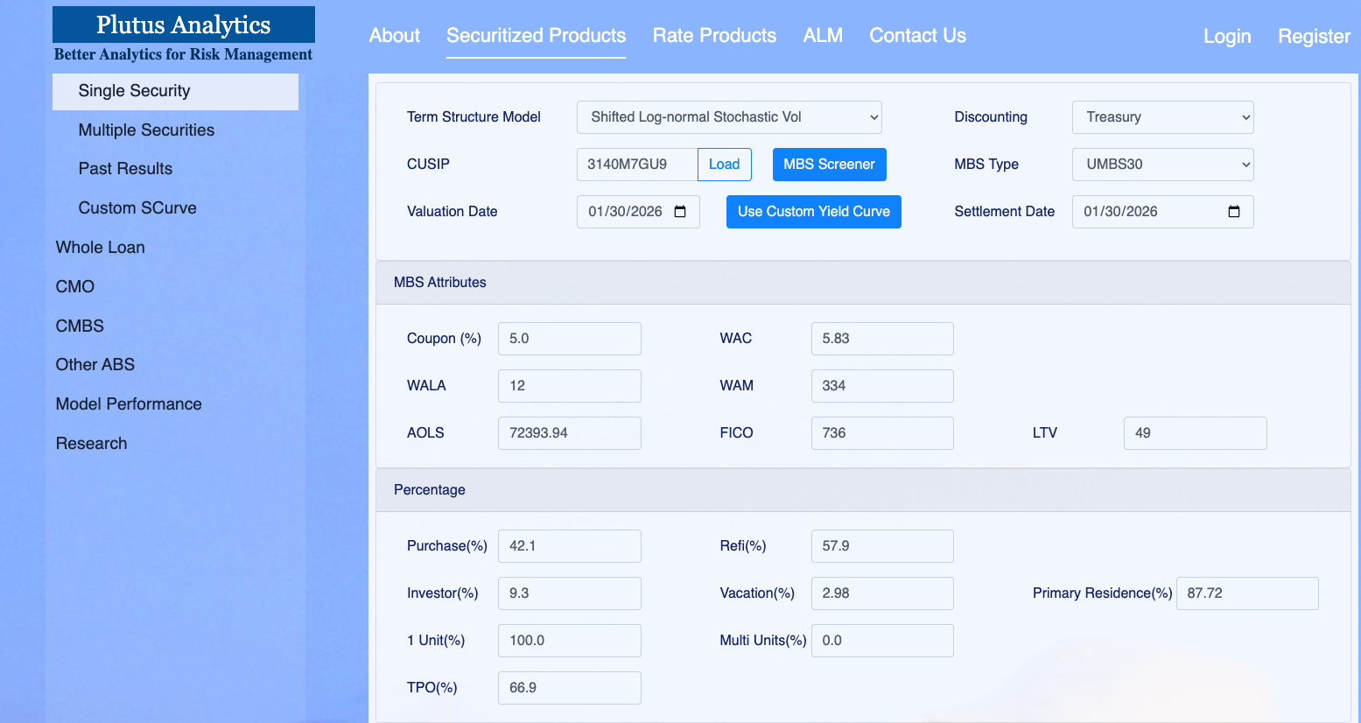

Chart 6-2: Price / Yield Table for CUSIP 314M7GU9, as of 1/30/2026, assuming base (0) price of par (100), and along with risk/return measures in up/down 100, 200, 300 bps parallel interest rate shock scenarios
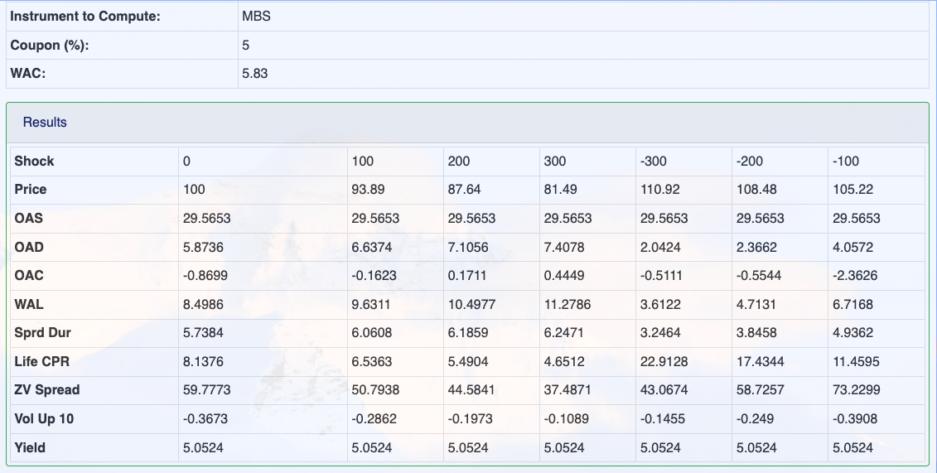

According to Page 9 of the class 7 presentation deck (also shown below), there is prepayment risk of an agency MBS. More specifically, there is contraction risk and extension risk, which causes negative convexity.
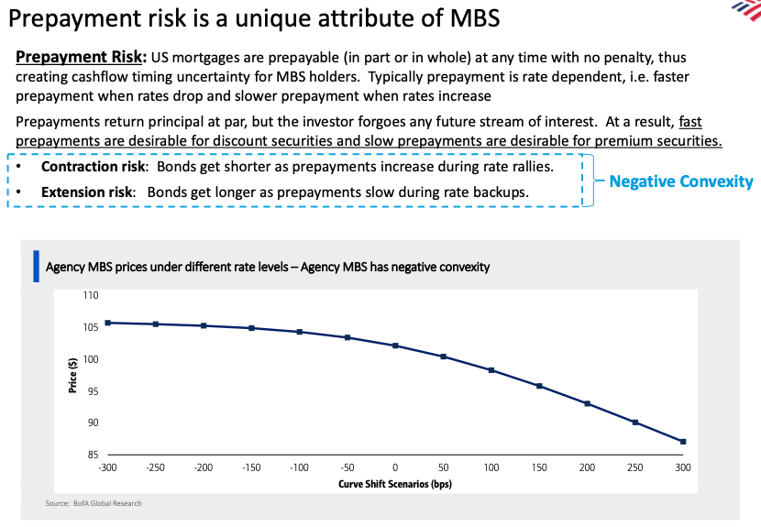

Question 6-1: draw a similar chart of Price against Curve Shift Scenarios (bps) as above using the sample MBS information in Chart 6-2. (5 points)

Question 6-2: Describe the contraction risk and extension risk through each of the four measures: OAD, OAC, WAL and Life CPR in Chart 6-2. (5 points)

Question 6-3: As you can observe, Yield is constant at 5.0524 across curve shift scenarios. Why isn’t it affected by contraction risk and extension risk? (5 points)

Chart 6-3: Price / Yield Table for CUSIP 314M7GU9, as of 1/30/2026, assuming base (0) price of 105, and along with risk/return measures in up/down 100, 200, 300 bps parallel interest rate shock scenarios

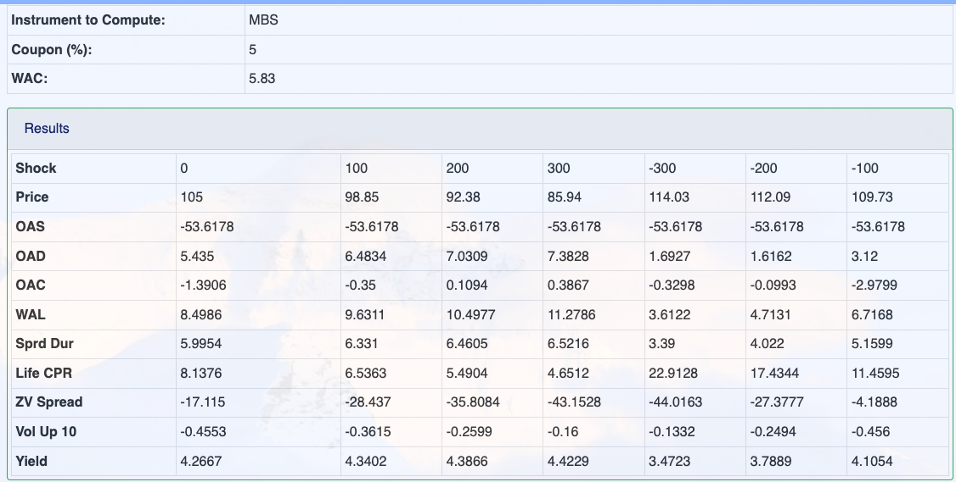

Question 6-4: (5 points) If the agency MBS’s price is 105 as of 1/30/2026, instead, then answer the following questions:
- Why are the values of WAL and Life CPR in Chart 6-3 the same as those in Chart 6-2?
- Why does the Yield increase when curve shifts up while decrease when curve shifts down?

